2021

ANNUAL

REPORT

2021

PUEBLO COUNTY CORONER’S OFFICE
PUEBLO COUNTY CORONER’S OFFICE

CORONER BRIAN COTTER

480 Midtown Circle, Pueblo 81003

719-583-4673

coroner@pueblocounty.us

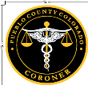
2021 ANNUAL REPORT

MISSION STATEMENT
T
o provide accurate, professional, and compassionate Medicolegal Death Investigations. To collect and provide evidence to individuals or agencies who need it to further criminal or civil proceedings. To serve those most affected by a death to the absolute best of our ability in bringing closure to families in difficult situations.

Function of the office

T
he Office of the County Coroner is established by the Constitution of the State of Colorado. The Coroner is elected to serve by the citizens of Pueblo County. The Coroner’s Office is a separate and independent division of the Pueblo County Government and is funded through the General Fund. The Coroner, a Chief Deputy Coroner, three full-time Deputy Investigators, four part-time Deputy Investigators, and a full-time Administrative Assistant staff this department.

The Coroner and staff recognize the tragedy surrounding an untimely death and perform investigations, in part, to assist the grieving family. A complete forensic investigation provides for the expeditious settling of insurance claims and estates, as well the implementation of civil and criminal actions. Questions which seem irrelevant in the initial hours after death can become significant in the following months. The surviving family and general public can have the peace of mind that a complete investigation was done. The Coroner works in cooperation with the law enforcement community but conducts a separate and unbiased investigation.

The Coroner has the authority to review and/or investigate any death if circumstances warrant. By Colorado Revised Statute, the Coroner’s Office determines the cause of death in all of the following circumstances:
- Disease that may be hazardous or contagious, or that may constitute a threat to the health of the general public
- Any external violence, unexplained cause or suspicious circumstances or any type of accident
- When no physician is in attendance, or the physician in attendance is unable to certify the cause of death
- Thermal, chemical, radiation injury or criminal abortion
- When death occurs while in the custody of law enforcement officials or while incarcerated in a public institution
- When death is sudden and occurs while person is deemed in good health
- When death occurs in a hospital less than 24 hours after admission

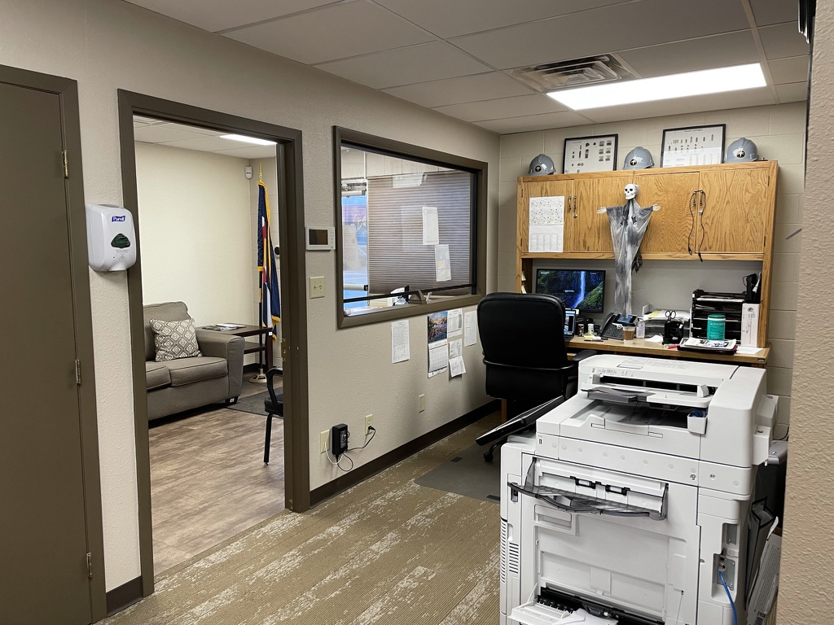
Although criminal death investigations constitute a small portion of deaths investigated by the Coroner, these deaths are studied in great detail because of the issues and legal consequences involved. By this action, the criminal justice system is offered the best support. The public health dimension of the Coroner’s function is designed to isolate and identify causes of sudden unexpected death. When an infectious agent or poison is implicated in a death, the family and persons recently in physical contact with the deceased are notified in order that they might receive any needed medical treatment.

Staff of the Pueblo County Coroner

Elected Coroner: Brian Cotter
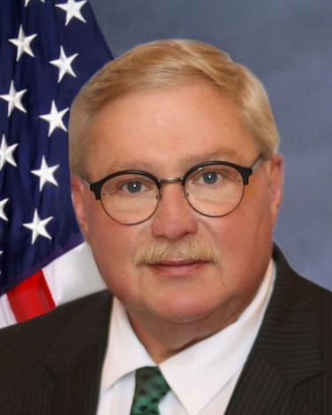

Chief Deputy Coroner: Ken Espinoza

Deputy Coroner (Full time): Felicia McQueen

Deputy Coroner (Full time): Troy Puga

Deputy Coroner (Full time): Brian Cruz

Deputy Coroner (Part time): Rob Hudgens

Deputy Coroner (Part time): Jeff Capito

Deputy Coroner (Part time): Mike Hood

Deputy Coroner (Part time): Kari Novak

Administrative Assistant: Natalie Jensen

expenditures

The total 2021 expenditures for the Pueblo County Coroner’s Office was $972,157.00. Of this, 48% was personnel expenses, 43% was for autopsies and related expenses, and 9% was general operating expenses. These expenses included an increase in cases of 206 over 2020. There was an increase in personnel in 2021 due to the approval of two additional full time investigators and increased number of deaths related to COVID 19, but a decrease in operating cases due to our staff and equipment being utilized.

DesCription of reportable cases

In accordance with Colorado Revised Statue 30-10-606, the following deaths are required to be reported to the Pueblo County Coroner’s Office:

  - Death is or may be unnatural as a result of external influence, violence or injury;
  - Death is due to the influence of or the result of intoxication by alcohol, drugs or poison;
  - Death as a result of an accident, including those occurring at the workplace;
  - Death of an infant or child is unexpected or unexplained;
  - Death where no physician in attendance or when, though in attendance, the physician I unable to certify the cause of death;
  - Death that occurs within twenty-four hours of admission to a hospital;
  - Death that occurs within forty-eight hours of a surgical invasive procedure;
  - Death from a disease which may be hazardous or contagious or which may constitute a threat to the health of the general public;
  - Death occurs from the action of a peace officer or while in custody of law enforcement officials or while incarcerated in a public institution.
  - Death was sudden and happened to a person who was in apparent good health;
  - When a body is unidentifiable, decomposed, charred, or skeletonized;
  - Circumstances that the coroner otherwise determines may warrant further inquiry to determine cause and manner of death or further law enforcement investigation.

It should be noted that even though a death is “reportable” under these guidelines, an autopsy may be unnecessary depending upon the circumstances.

yearly trends

The change in case numbers seen from 2021 reflects a 44% increase from 2019 and a 15% increase from 2020. These increases continue to somewhat be attributed to the COVID 19 pandemic and it’s related co-morbidities. We also saw increases in homicides and motor vehicle accident fatalities in 2021.

2021 MONTHLY TRENDS

The increase in cases during the winter months of January, October, November and December were predominantly natural deaths of which occurred in local hospitals and could be attributed to complications related to COVID 19. While 395 COVID 19 positive cases were reported to this office, these numbers will vary slightly from the Colorado Department of Health statistics due to a variation in reporting regarding county of residence of the decedent.

AUTOPSIES

O
f the 2,813 deaths in Pueblo County that were reported to the Colorado Department of Heath, an autopsy on some level was performed on 10% of the cases. Depending on the circumstances of the death, 265 full autopsies were performed along with 4 external exams and 16 cranial exams. Autopsies are conducted to determine manner and cause of death, to document disease, to identify injury patterns, or to recover evidence. Along with the physical autopsy, toxicology testing and histology review are performed which may also be useful in determining manner and cause of death. Toxicology tests include those indicating the role of alcohol, illicit drugs, commonly abused prescription and non-prescription drugs, and other abused substances/poisons as needed.

Colorado House Bill 11-1258 was passed in 2011 which mandates forensic autopsies be performed by a board-certified forensic pathologist. This mandate is now also incorporated in Colorado Revised Statute 30-10-606.

By statute, a forensic pathologist shall perform a forensic autopsy in the following cases:
- The death is known or suspected to have been caused by apparent
criminal violence.
- The death is unexpected and unexplained in an infant or child.
- The death is associated with police action.
- The death is apparently non-natural and in custody of a local, state,
or federal institution.
- The death is due to acute workplace injury.
- The death is caused by apparent electrocution.
- The death is caused by apparent intoxication by alcohol, drugs, or poison, unless a significant interval has passed, and the medical findings and absence
of trauma are well documented.
- The death is caused by unwitnessed or suspected drowning.
- The body is unidentified, and the autopsy may aid in identification.
- The body is skeletonized.
- The forensic pathologist deems a forensic autopsy is necessary to determine
manner and cause of death, to document injuries/disease, or to collect
evidence.
- The deceased is involved in a motor vehicle incident and an autopsy is necessary to document injuries and/or determine the cause of death.
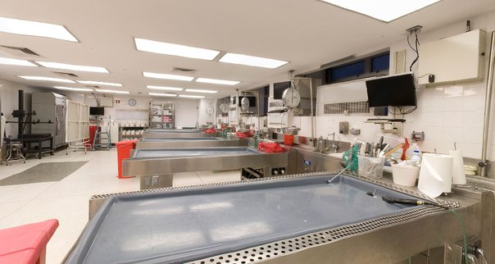

MANNER OF DEATH
T
he state of Colorado recognizes five classifications of manner of death. They are: Natural, Suicide, Accidental, Homicide, and Undetermined. A death is classified as one of these based on the circumstances surrounding the death and how that cause came to be. Determining manner of death is one of the main responsibilities of the Pueblo County Coroner’s Office and is one of the items that must be reported on the death certificate.

DETAILED BREAKDOWN OF MANNER

NATURAL DEATHS

SUICIDE DEATHS

While suicides historically occur primarily with males over the age of 30 years, in 2021 Pueblo County lost four males under the age of 18; one involved a hanging and three involved a handgun. Pueblo County also saw an increase in both younger males (18-50 yrs) and older males (80-89 yrs).

ACCIDENTAL DEATHS

Accidental deaths comprise the second largest population and can result from a myriad of causes. As can be seen in the graph, overdoses account for the greatest number, with poly drug overdoses comprising the majority of this number. Drug overdoses will be focused on later in this report. The causal category of trauma is in itself varied with most being the result of a motor vehicle accident of some type. The youngest victim of an accidental death was 1 day old while the oldest was 96 years. Males comprise the largest population at 103 accidental deaths while females made up 50 of this deaths.

HOMICIDES

As is reflected in the following graphs, there was an increase in homicides in Pueblo County with an all-time high of 26 deaths. Males account for 88% of the victims with the average age falling in the 26-50 year range. Guns were involved in 77% of cases.

DEATHS OF UNDETERMINED MANNER
I
t is the goal of the Pueblo County Coroner’s Office to provide family of the decedent a cause and manner of death. Unfortunately, there are a few cases in which the cause of death cannot be determined despite a complete autopsy, comprehensive toxicology/histology tests, and a thorough multidisciplinary scene investigation. There are also cases in which the cause of death is obvious, but the manner of death could not be determined due to lack of evidence. The determination of manner of death is made “on the preponderance” of evidence, and when this is unattainable, the manner is listed as undetermined. An example of such a case is an obvious drug overdose, but with the evidence documented, the manner is unable to be determined between suicide and accident.

Of the five cases with undetermined manner of death, three were male and two were female. The range in age was 17 to 62 years of age.

DRUGS OF ABUSE: POLYDRUG DEATHS
Of the 71 deaths in 2021 attributed to an overdose of drugs, 39 involved the lethal level of more than one drug. This is an increase of All overdose deaths are considered accidental unless evidence shows they were intentional. The most common drugs involved in polydrug deaths are ethanol, opiates, and stimulants (methamphetamine and cocaine).

OVERDOSES BY DRUG - TOTAL 38

CHILD DEATHS
T
he Pueblo County Coroner’s Office investigated eighteen deaths involving children under the age of 18 years. Of those, 12 were males and six females. Eight cases involved children one year and younger, three cases two to ten years, and seven cases 11-17 years of age.

